Using Your OneDrive Account

- Open your internet browser and log on to your school email account.
- Once you are logged in your screen should look like this.
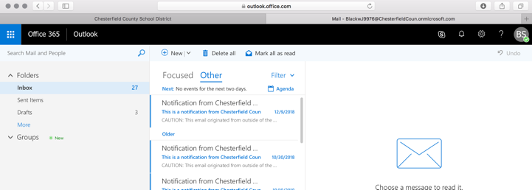

- In the top left corner is a blue box with white dots. Click this box and a drop-down menu will appear.
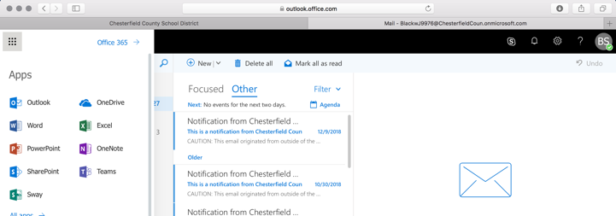
- Select “OneDrive” option on the menu.

- The first time you log in the screen below will appear. It is providing you with information about your one drive account. Continue to select “Next” until you can select “Let’s Get Started”.
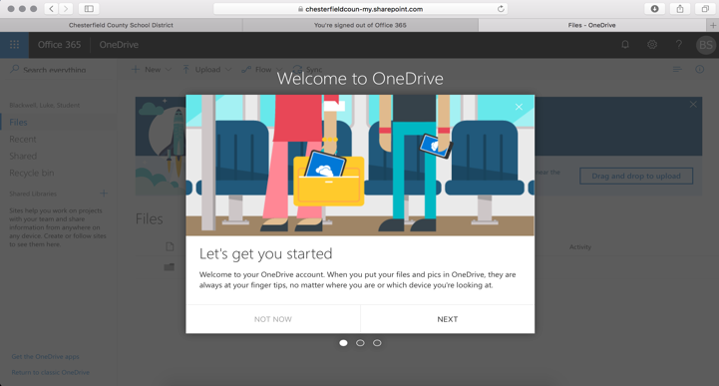

- You now have full access to your OneDrive account. When using the online Microsoft Office Applications, your documents will automatically save to your OneDrive Account.
- You can upload additional files from your computers to your OneDrive.
- Your OneDrive can be accessed from anywhere that you are able to log on to your email.

