Singing on to Your School Email

- Open your internet browser and log on to www.chesterfieldschools.org.

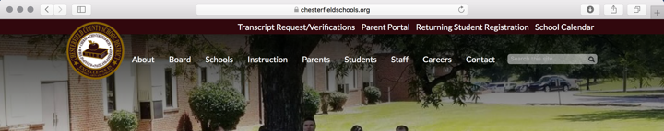

- Scroll over the “Student” menu and select “Email Access”.

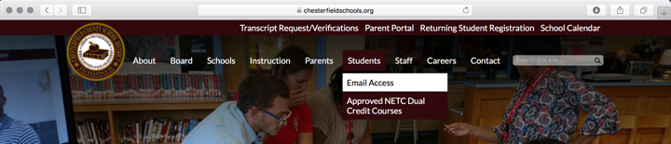

- Type in your email address. It is your user name @stu.chesterfieldschools.org then click “Next”.
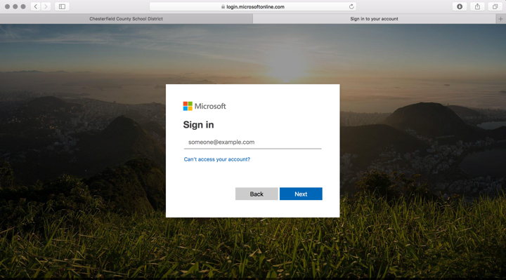

- Type in your password. It is the same password you use to log into a school computer.

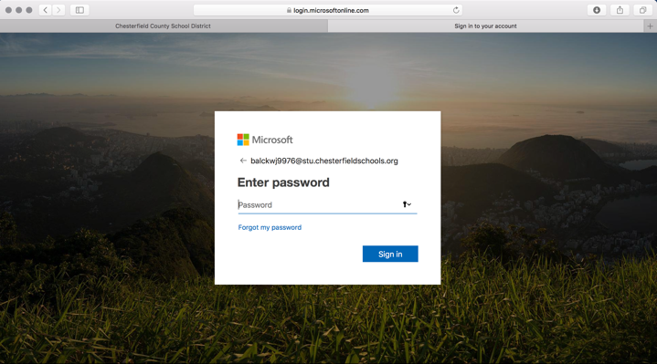

Tips:
- When you log on to a computer for the first time it will ask you to select Chesterfield County School District as the domain. You always want to click Chesterfield County Schools.
- The very first time that you log in you have to set up your language and time zone. This only has to be done one time.
- You have to include @stu.chesterfieldschools.org on your sign in page or it will not let you log in.

