How to Send an Email

- Make sure you are logged into your email. Use the “How to Login to Your School Email” guide to help you.
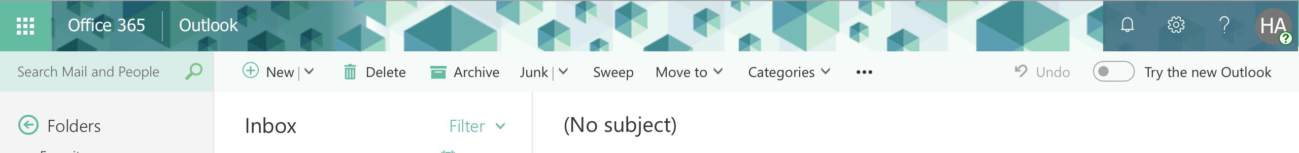
- Once you have logged in, select “New” at the top of the screen.

- Once you have selected “New,” you need to input the address of the person you want to send the email to. To send it to Ms. Hasul, begin typing “Hasul,” and it should pop up. Click on my name.

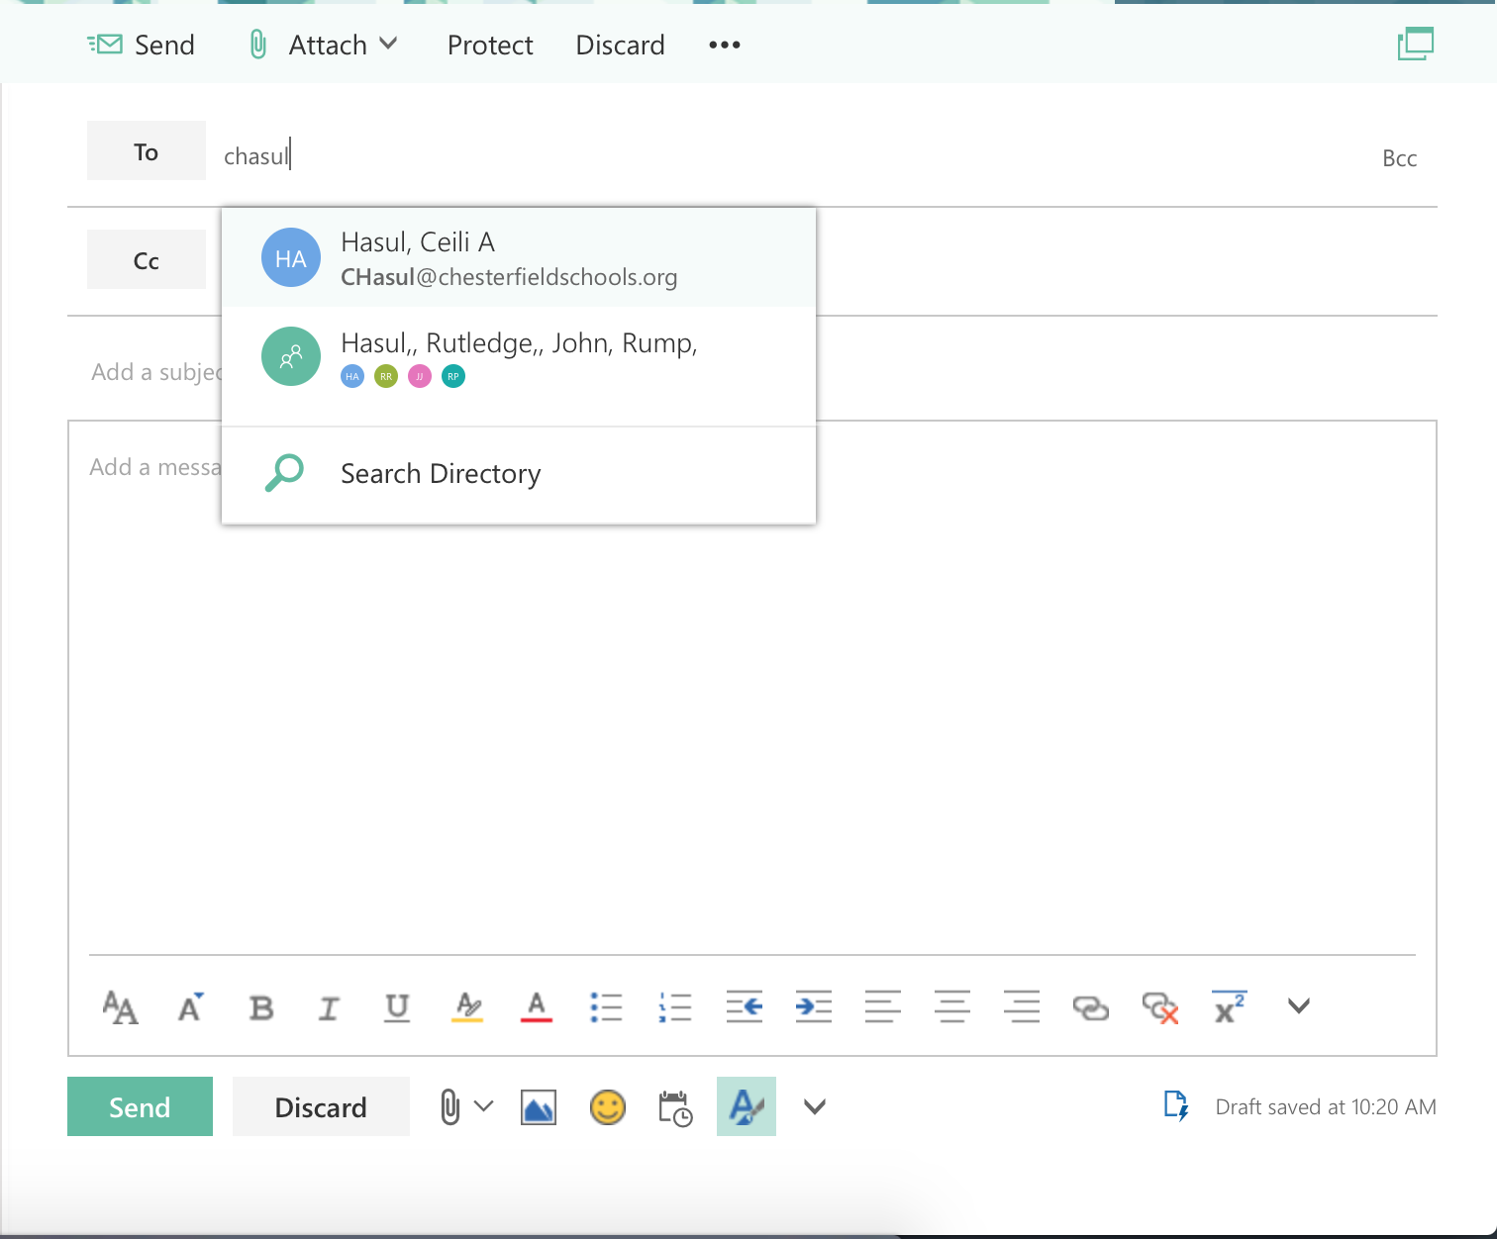

- To add an attachment to your email, select “Attach” at the top of the email.
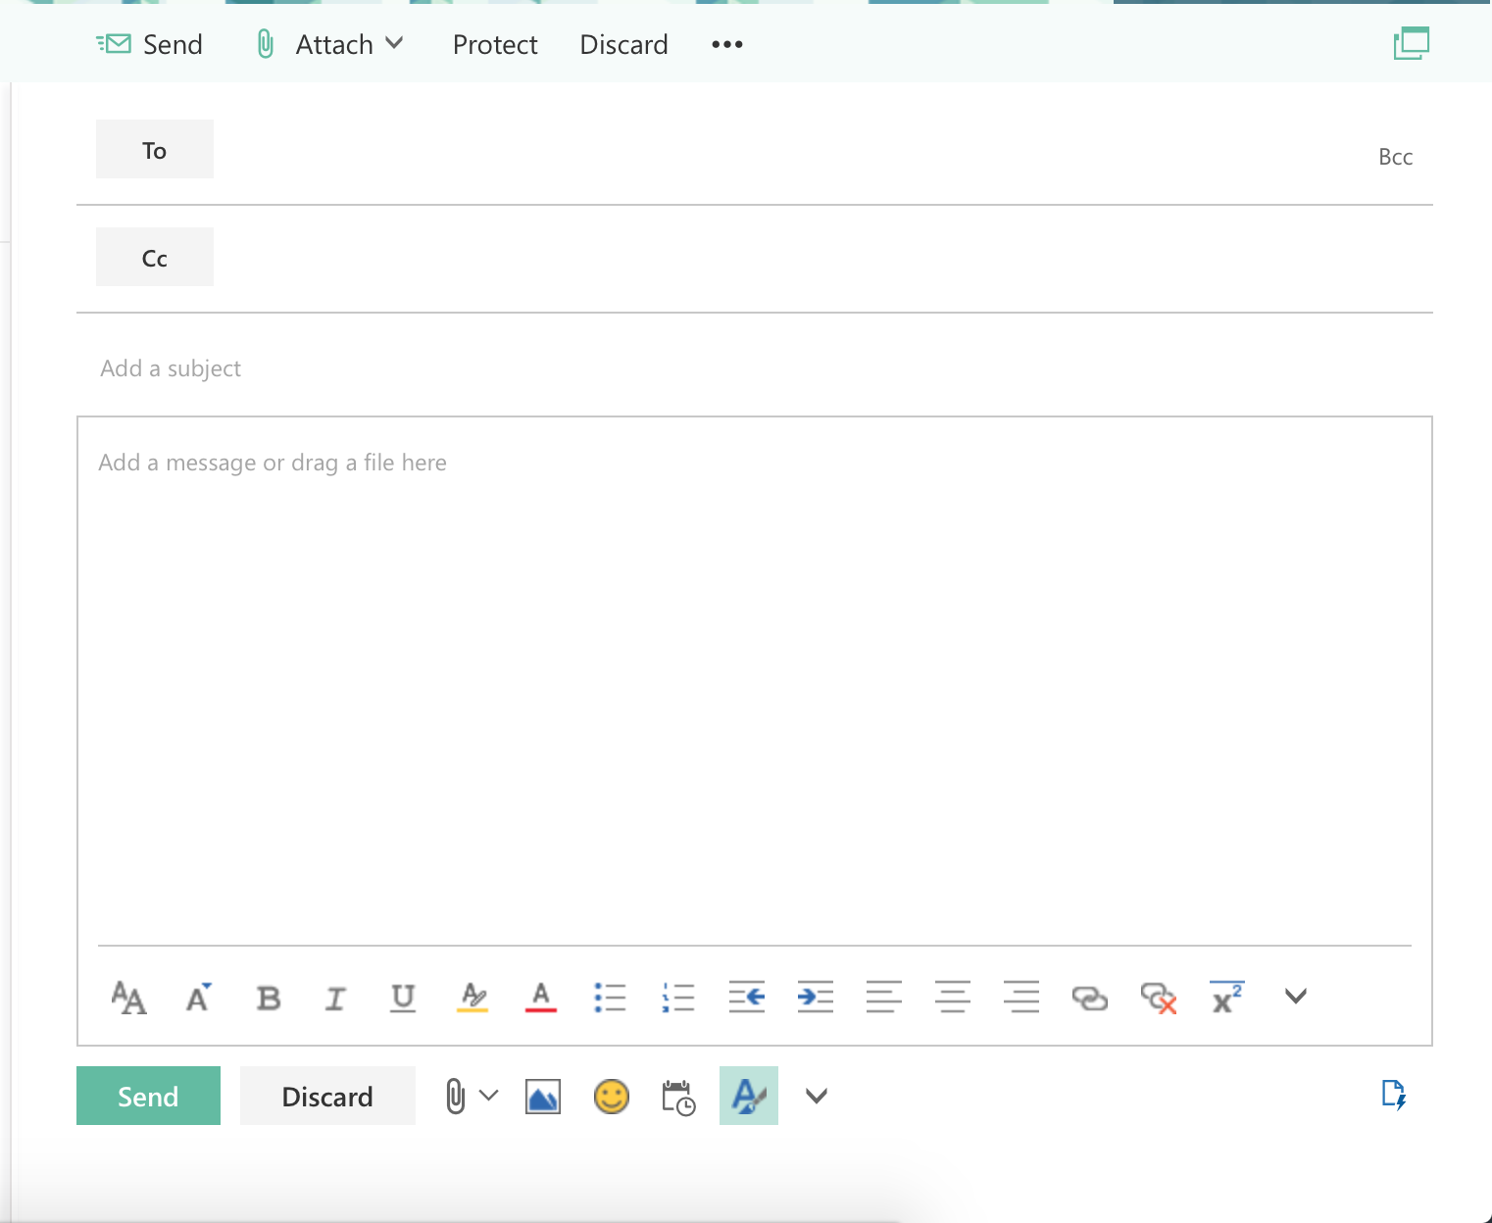

- IF your document is saved on your ONEDRIVE select “Cloud Locations.” IF your document is saved on the COMPUTER OR FLASH DRIVE select “Computer.”
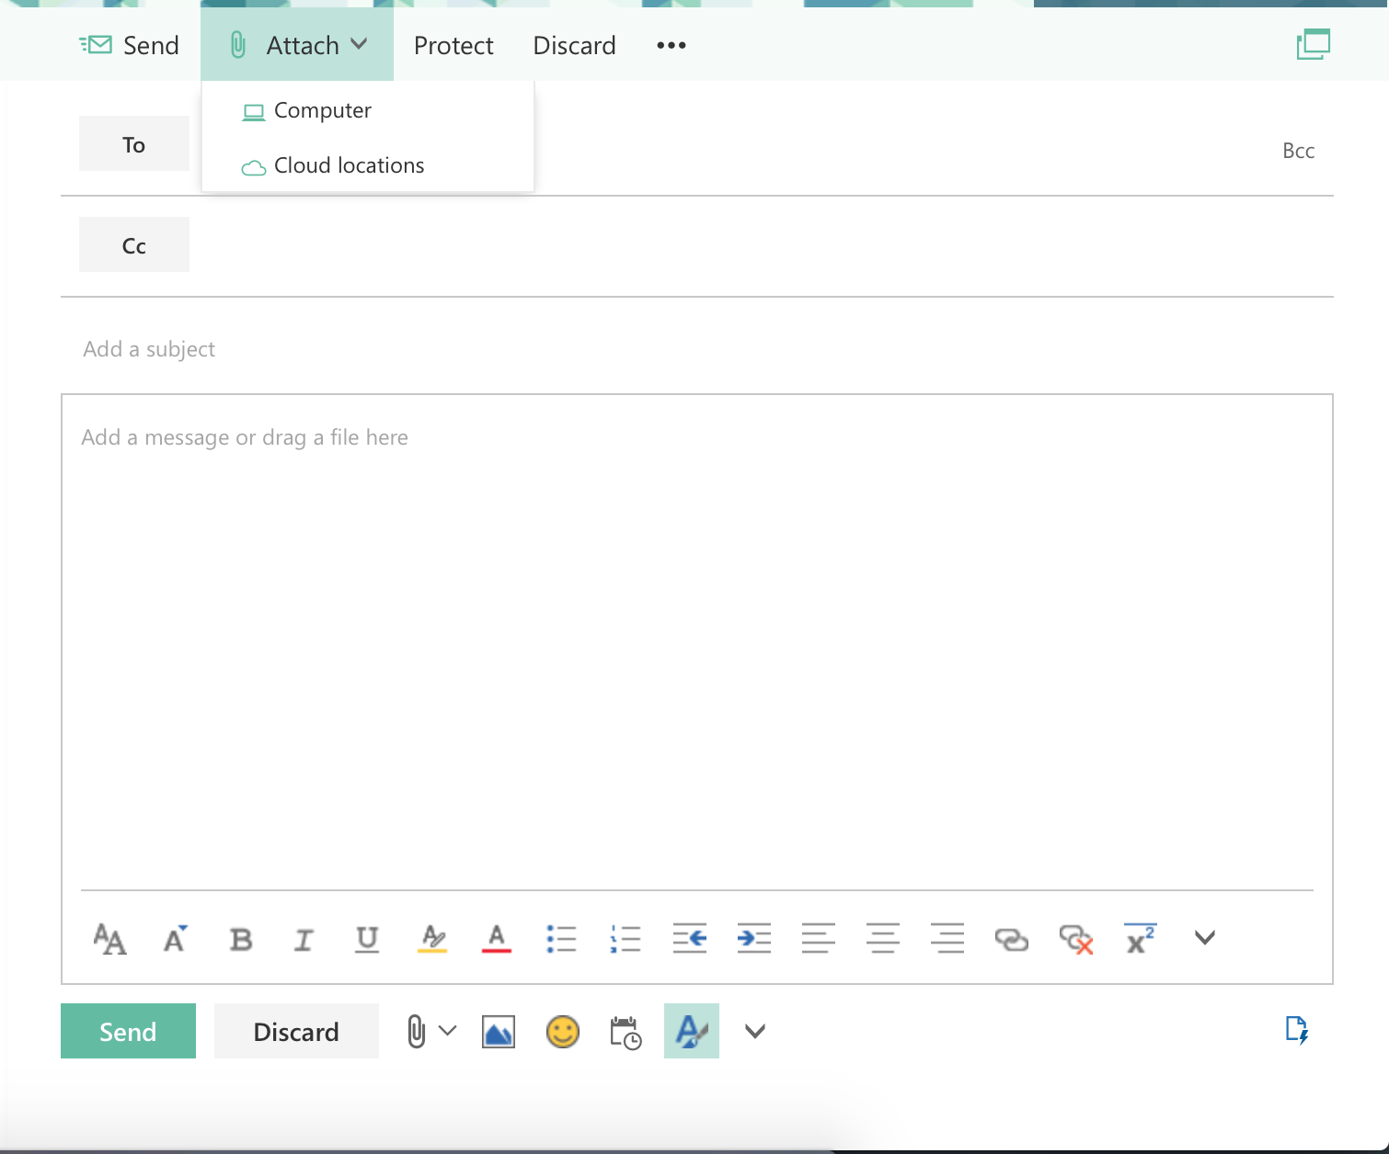
OneDrive
Computer or Flash Drive

- Select your document to be added to your email.
- “Add a Subject” so the receiver knows what the purpose of your email is.

- You can add any necessary information in the body of your email.

- Press “Send!”

